**THE TABLEAU HR SCORECARD:**

**Measuring success in talent management**

**1.INTRODUCTION:**

*Talent management includes all the ways that organizations bring employees on board, keep them happy and productive, and help them continue to develop their skills over time.*

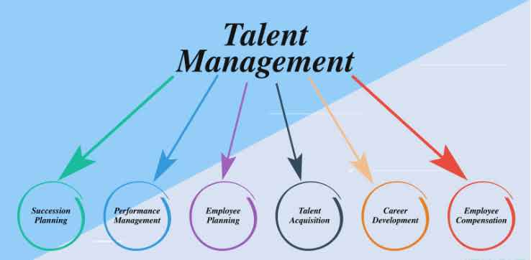

**2. PROJECT DEFINITION AND THINKING:**

**EMPATHY MAP:** 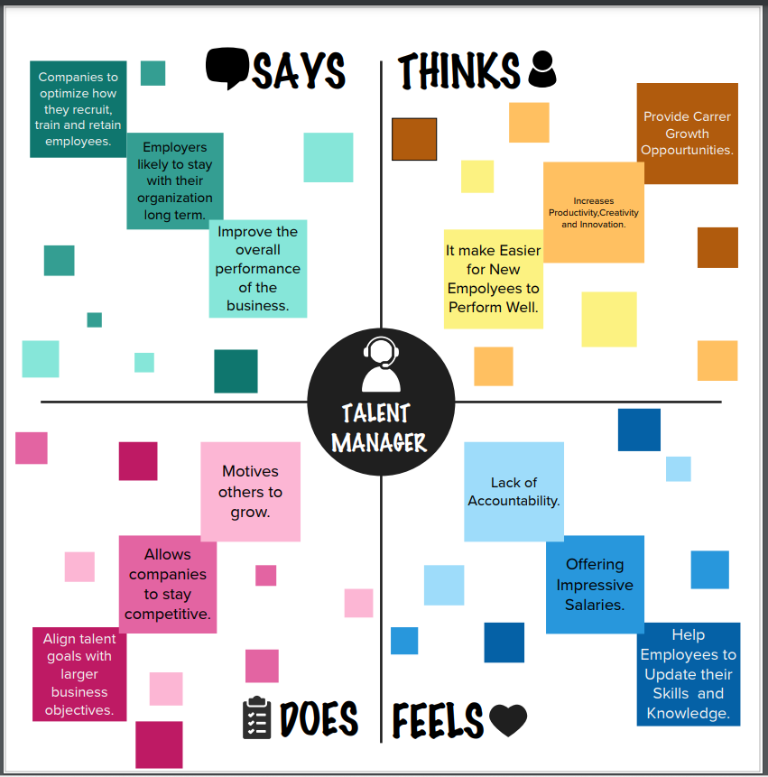

**IDEATION AND BRAINSTORMING MAP:**

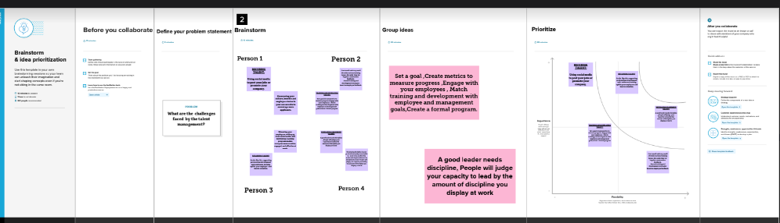

3. ***EMPATHY MAP:***

*Empathy maps are a visualization of knowledge about your users. They're created by organizations and teams through group exercises: The goal is for each contributor to gain insights into users' motivations and empathize with their frustrations.*

***BRAINSTORMING:***

*Brainstorming is a group creativity technique by which efforts are made to find a conclusion for a specific problem by gathering a list of ideas spontaneously contributed by its members. A group of people write ideas on sticky notes as part of a brainstorming session.*

**4.ADVANTAGES:**

* More understanding of the Target Audience.
* More Organized Information in easy to understand format.
* Fast and Inexpensive.
* Easy Customization.
* Common Understanding and same mindset of whole team members.

**5.DISADVANTAGES:**

brainstorming also has some drawbacks, such as groupthink, social loafing, and information overload. To overcome these challenges, you might consider using brainstorming tools and software that can enhance your team's problem-solving process.

**6.APPLICATIONS:**

Brainstorming throughout any design or work process, of course, to generate ideas for design solutions, but also any time you are trying to generate ideas, such as planning where to do empathy work, or thinking about product and services related to your project.

**An empathy map helps to map what a design team knows about the potential audience. This tool helps to understand the reason behind some actions a user takes deeply. This tool helps build Empathy towards users and helps design teams shift focus from the product to the users who are going to use the product.**

**7. RESULTS:**

Department wise attrition:

SHEET-1

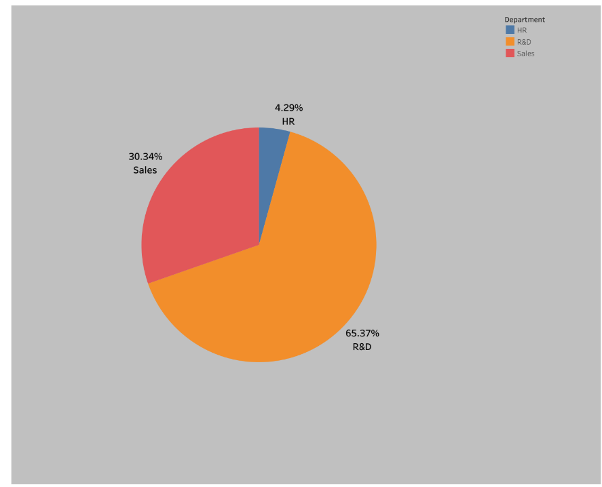

No of employees by age group:

SHEET-2

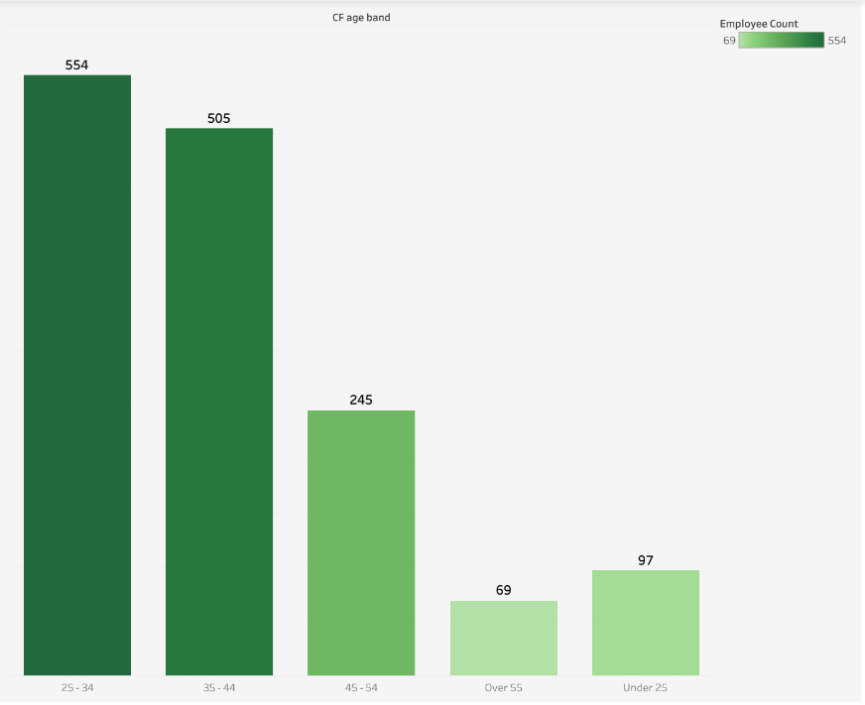

Job satisfaction rating:

SHEET-3

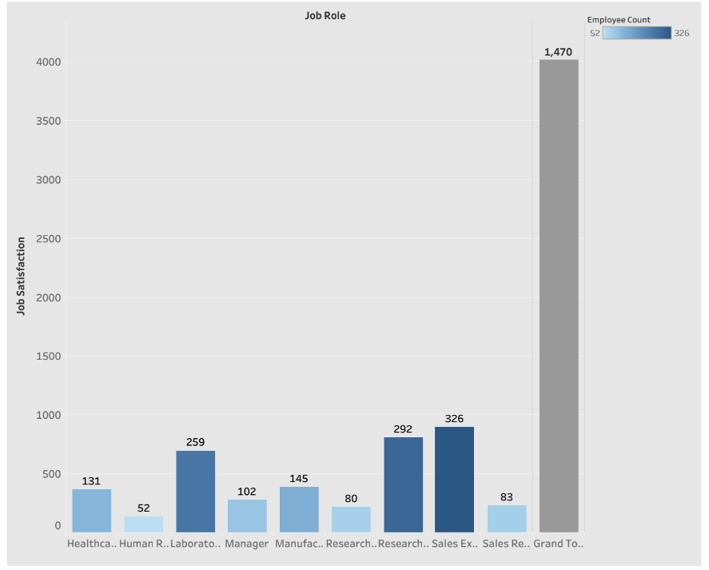

Education field wise attrition:

SHEET-4

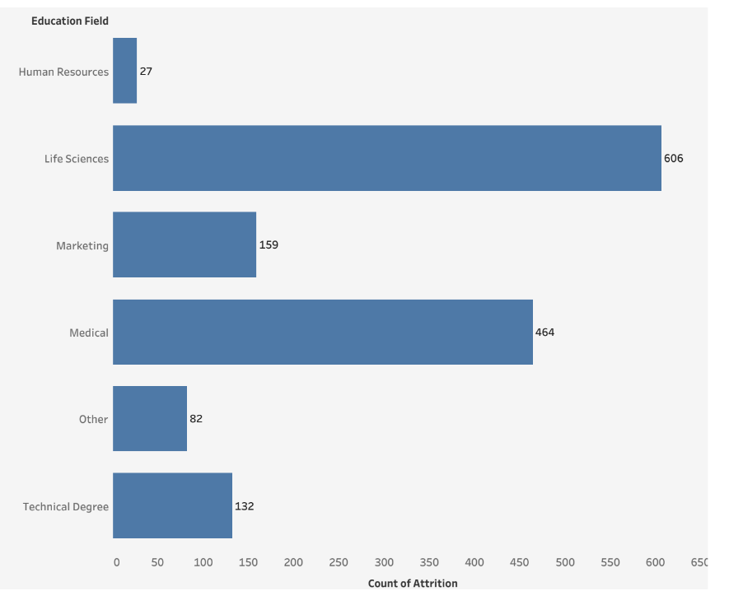

DASHBOARD:

**HR ANALYTICS DASHBOARD:**

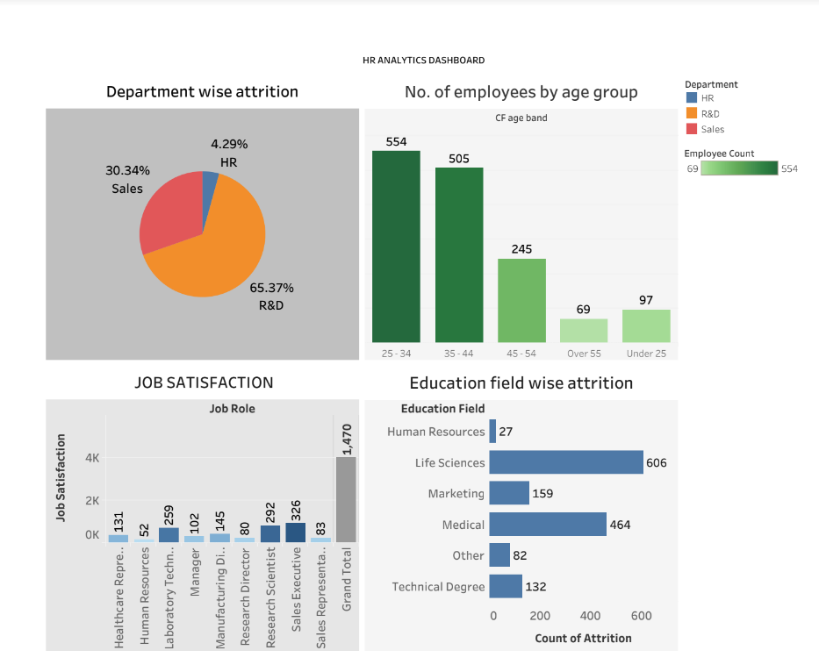

**STORY:**

**MEASURING SUCCESS IN TALENT MANAGEMENT**

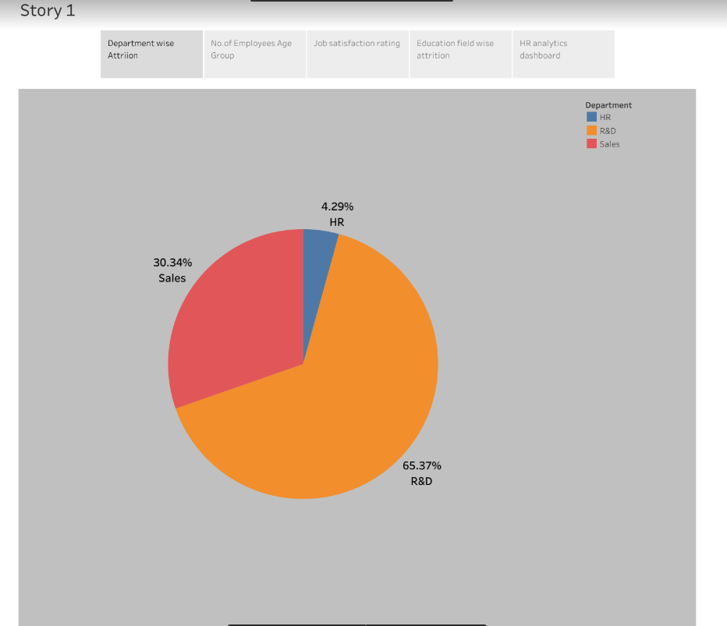

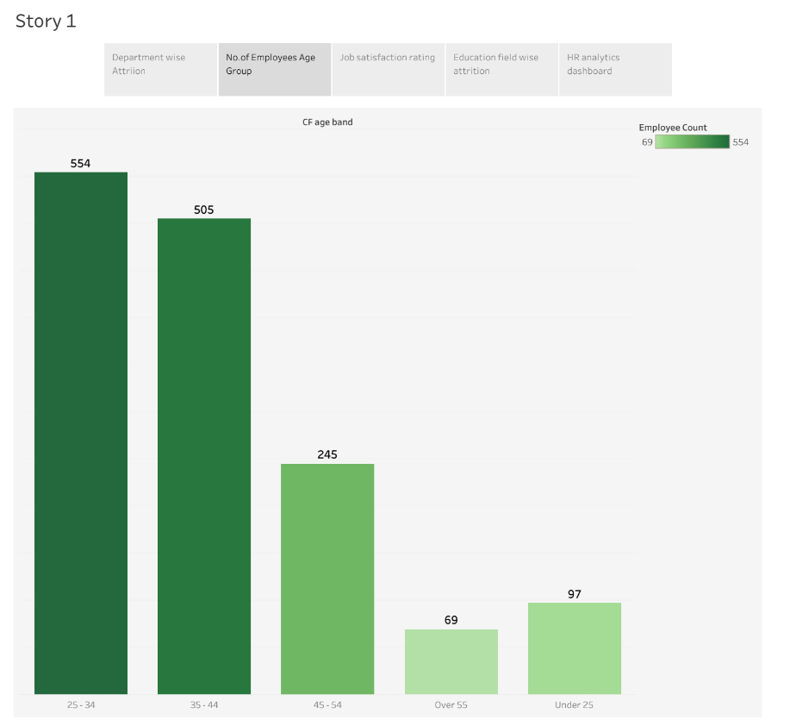

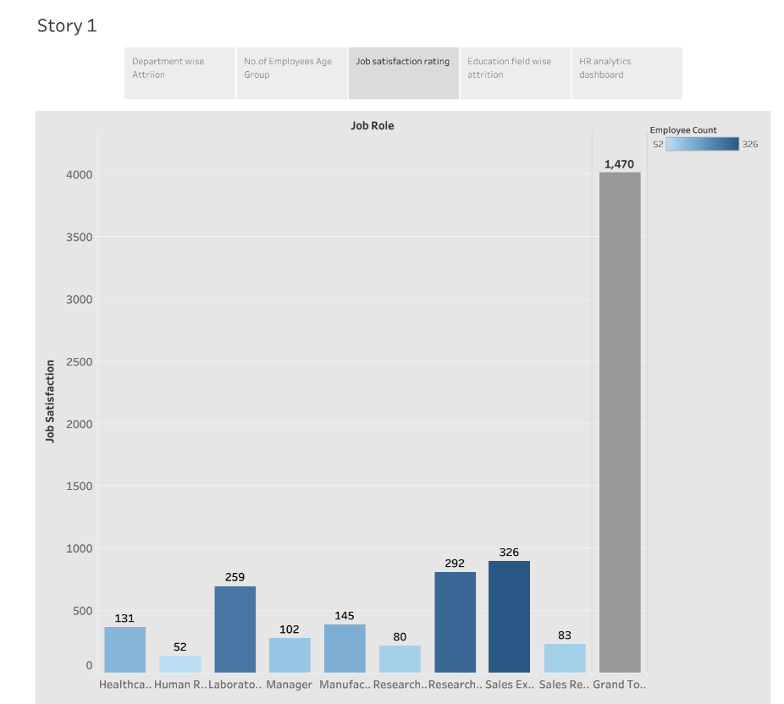

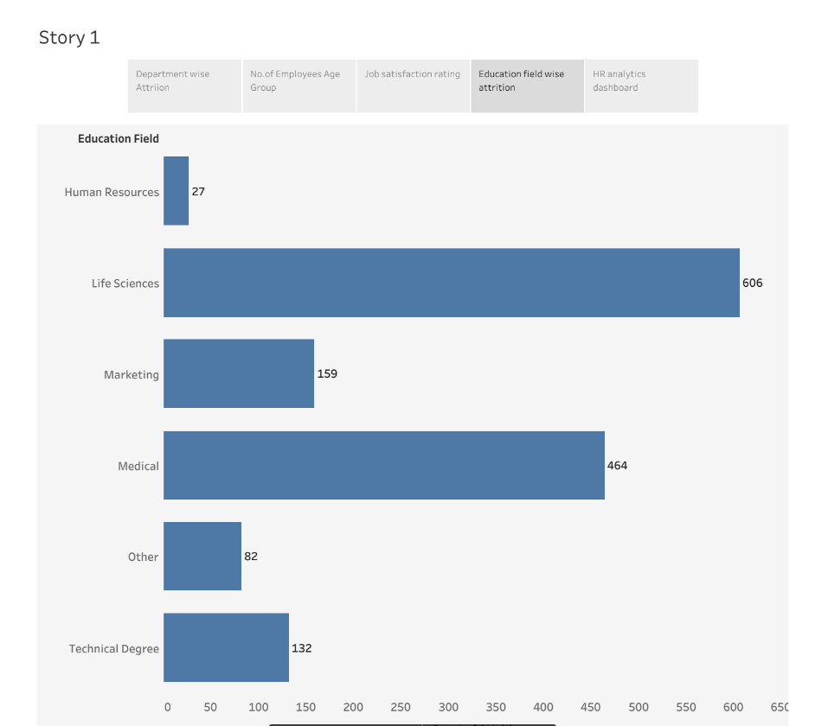

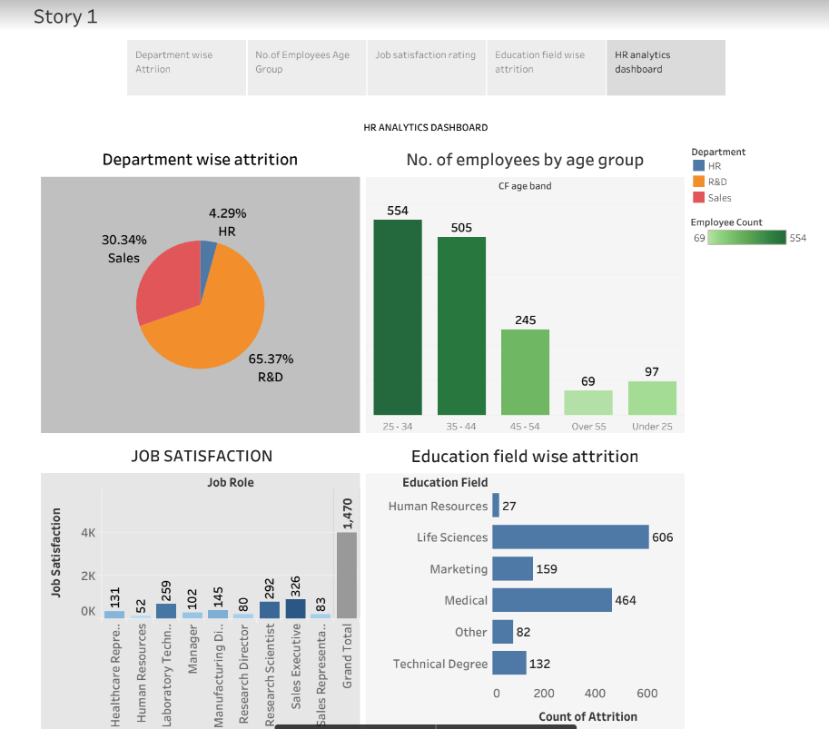

**8.CONCLUSION:**

At the end can say that talent management process has provide new ways to human resource department to handle the problems faced in hiring talent.

